SC of Output 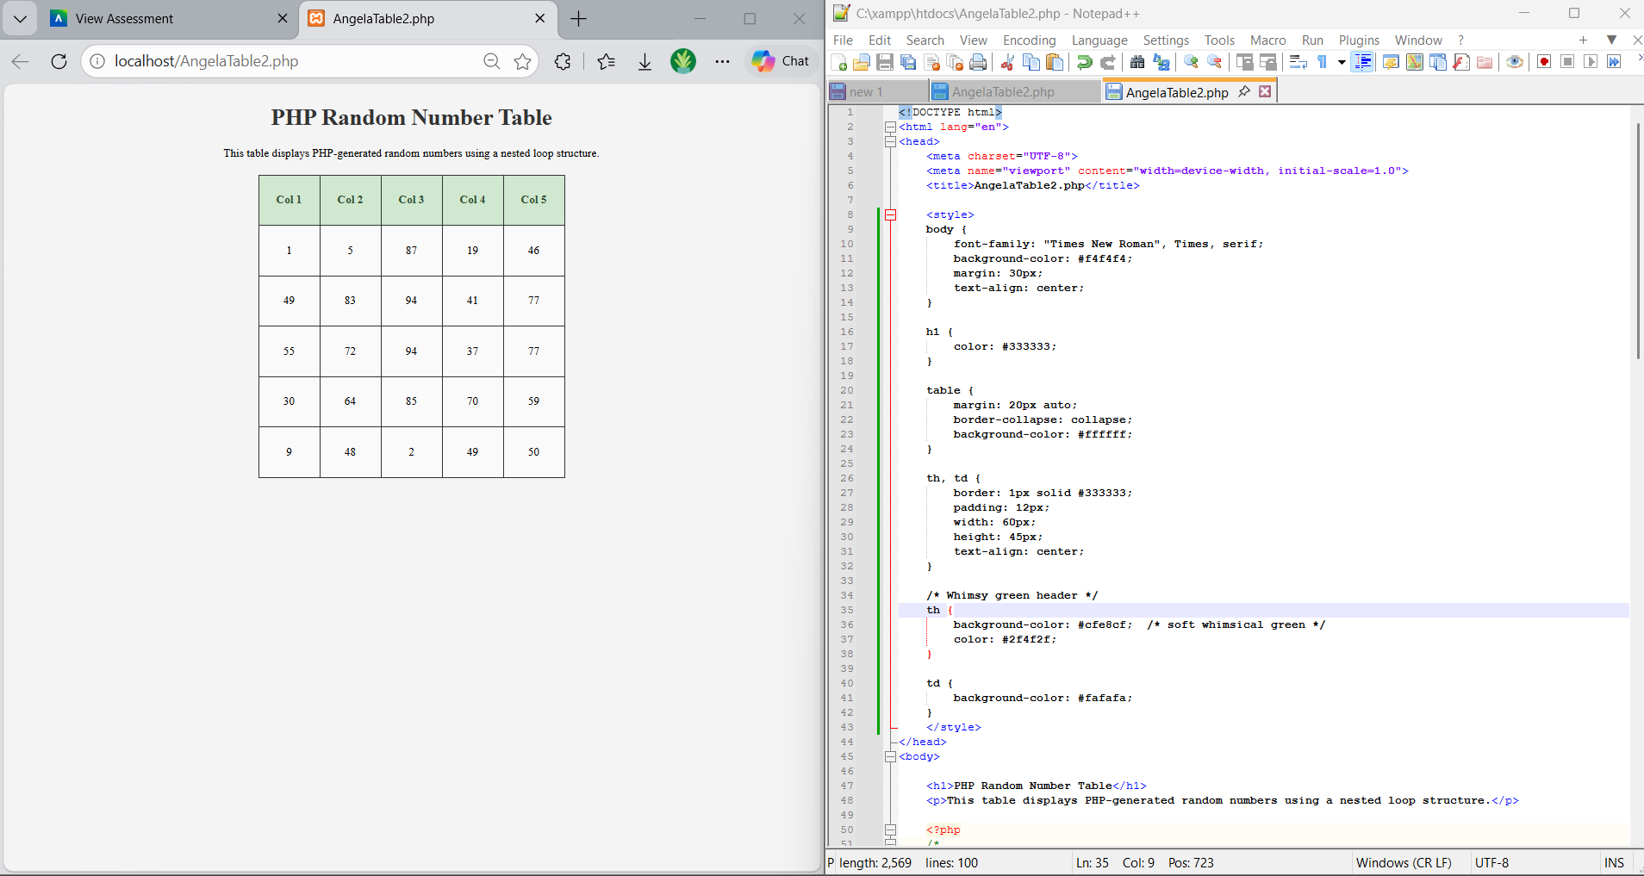

GitHub Link
ang166varg/CSD440: Repository for CSD-440 assignments

